Online ToDo List:

I have used the spring boot framework to implement the project.

I don’t have working experience with spring security and UI. I was mainly working on backend technologies It is working properly with the backend, but

I have written the server-side code and tested with Insomnia tool. It is working properly with the backend, but but the Ui pages are not stable. I have attached the screenshots of the UI behaviour in the last section of the document.

I am sorry to tell you that because of my thesis work and already scheduled part time shifts, I was not able to work completely on the assignment. I hardly got 2 full days for working on the assignment. Kindly review and give me the feedback.

By using the tool Insomnia, we can send the request also able to view the response.

For fetching the results:

Request: http://localhost:9090/task/

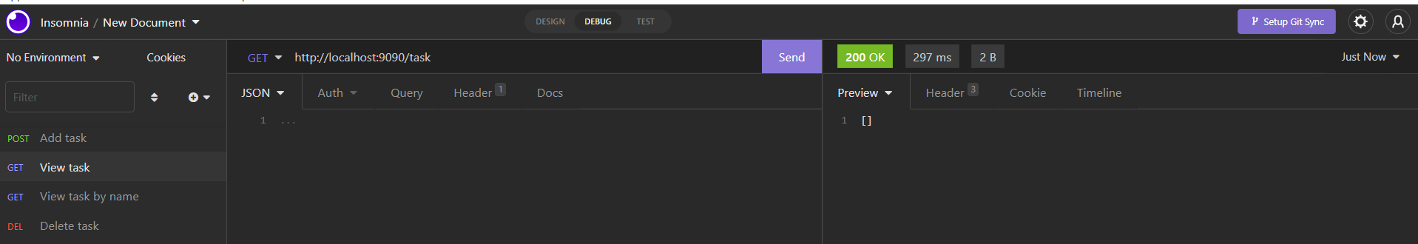No entries are there initially.

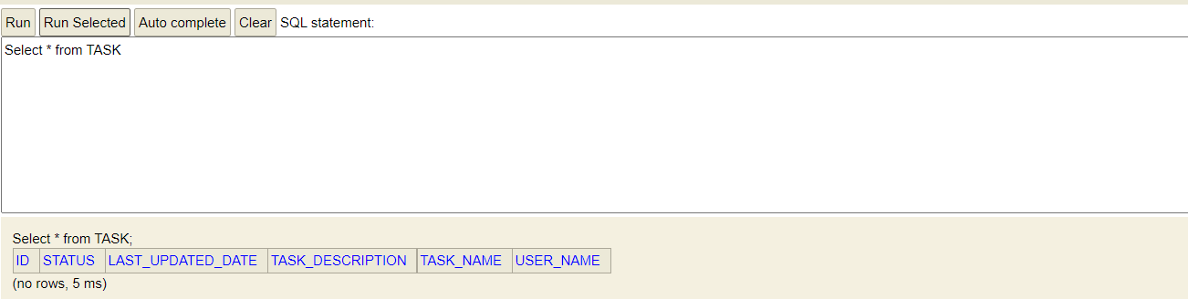Table can be viewed by using the url http://localhost:9090/h2-console.

Insert the values:

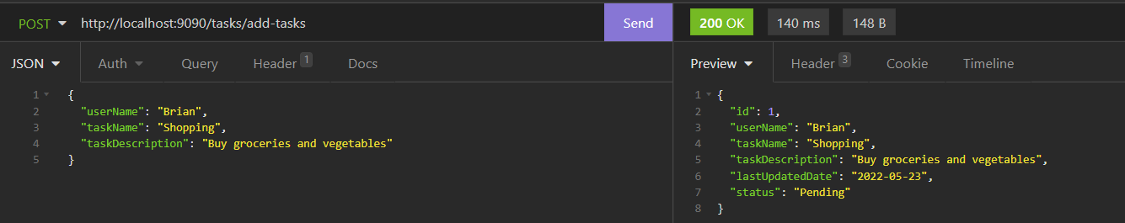

The following values are inserted in the same way:

{

"userName": "Brian",

"taskName": "Shopping",

"taskDescription": "Buy groceries and vegetables"

}

{ "userName": "Brian",

"taskName": "Bill",

"taskDescription": "Pay electricity bills by end of this week"

}

{ "userName": "Brian",

"taskName": "Mail,

"taskDescription": "Send mail to the manager"

}

{ "userName": "Richard",

"taskName": "Medicines",

"taskDescription": "Buy medicines which are prescribed by the doctor"

}

{ "userName": "Richard",

"taskName": "Repair",

"taskDescription": "Furniture repair"

}

{ "userName": "Eriga",

"taskName": "Wash Clothes",

"taskDescription": "Wash Clothes"

}

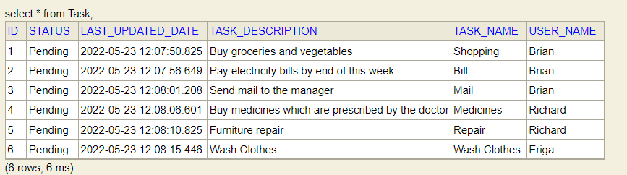

Fetch the details by using username:

http://localhost:9090/tasks/view-tasks/Brian

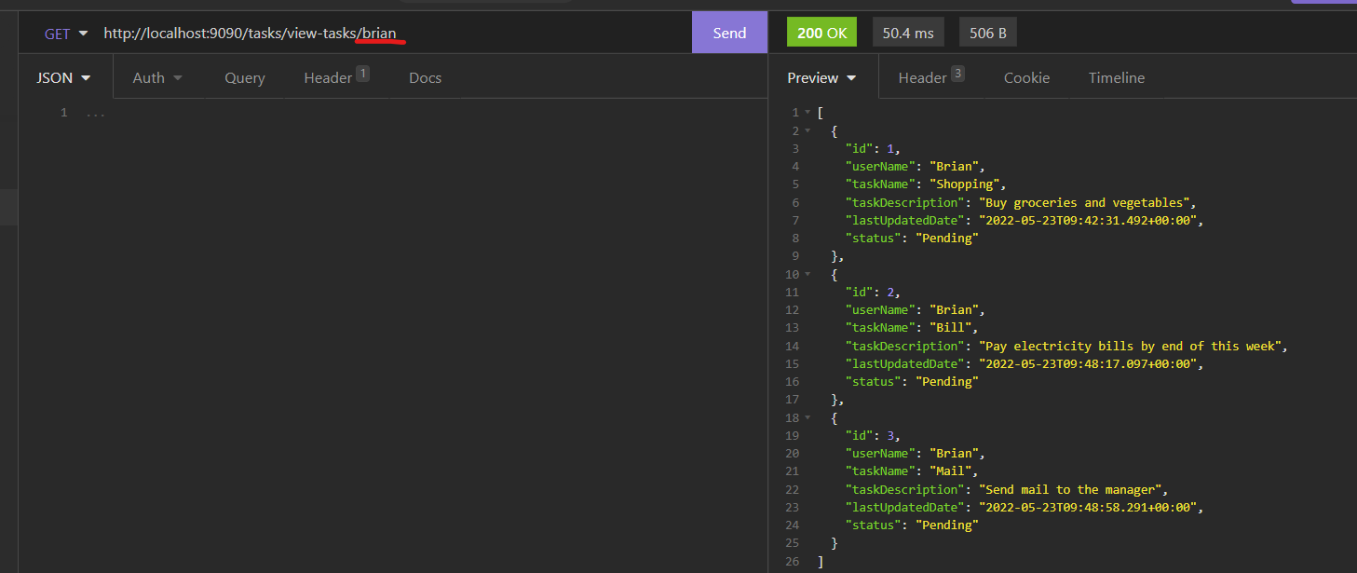

http://localhost:9090/tasks/view-tasks/eriga

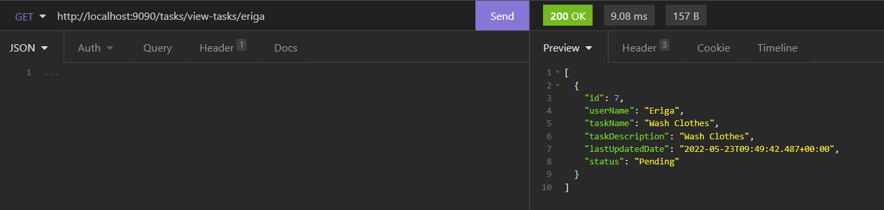

Closing the task:

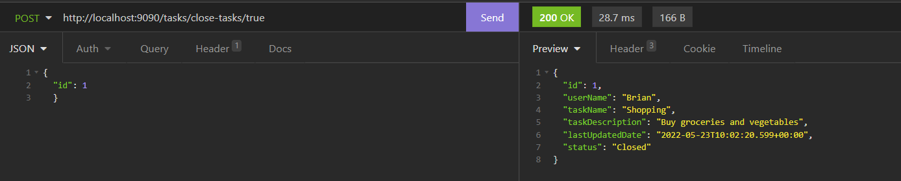The task status changed to closed from pending

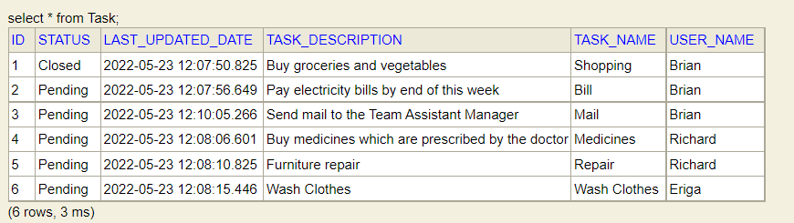

Edit Request:

The description has been changed from Manager to assistant manager:

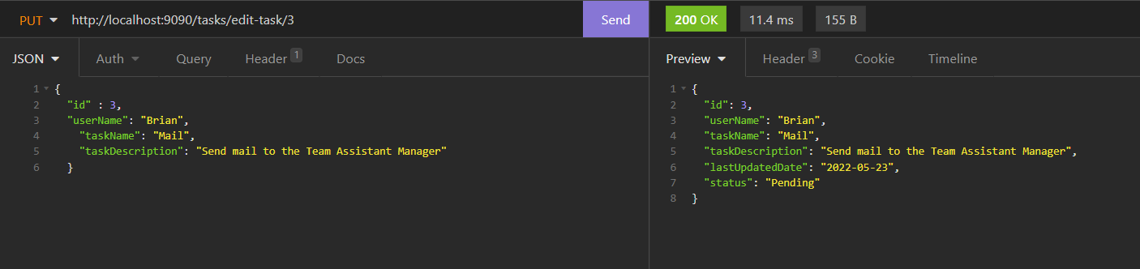

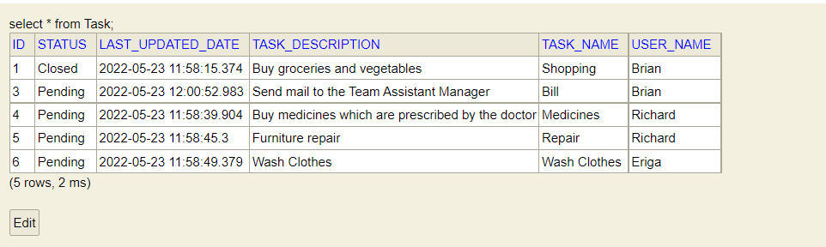

Delete task By ID:

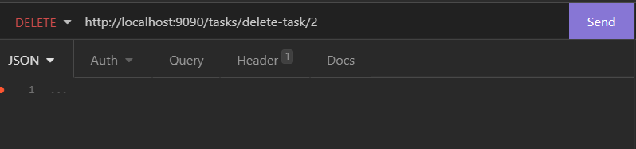<http://localhost:9090/tasks/delete-task/2>

The task with id 2 has been removed

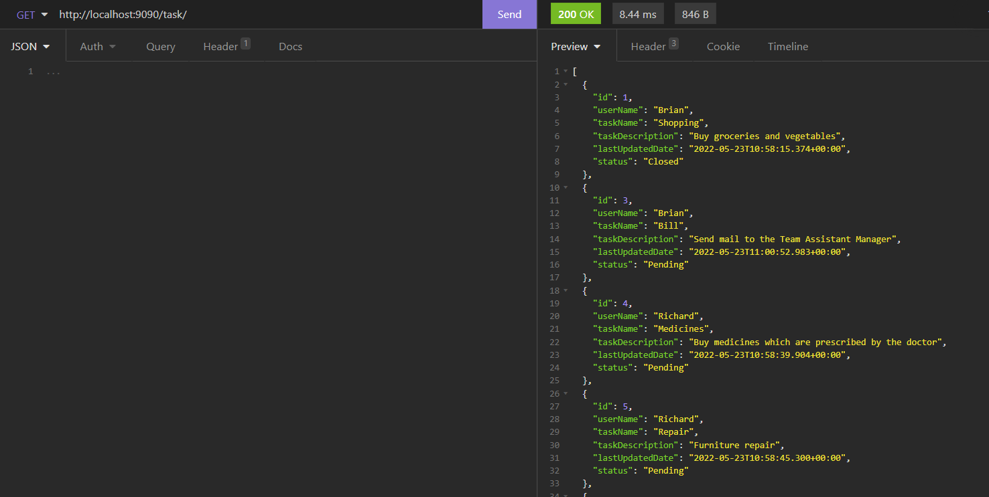

Application:

Login:

